SECTION – A
I. | Answer any five questions. Each question carries five marks. |  | 5 x 5 = 25 M
1. | Prove that every field an integral domain.
2. | If R is a Boolean then prove that (i) a + a = 0, a ∈ R ii) a + b = 0 ⇒ a = b.
3. | Prove that intersection of two sub rings of a ring R is also a sub ring of R.
4 | If f is ahomomorphism of a ring R into a ring R¹ then prove that Ker f is an ideal of R.
5. | Prove that curl (grand φ) =
6. | If f = xy² i + 2x²yz j – 3yz² k the find div f and curl f at the point (1, –1, 1)
7. | If R (u) = (u – u²) i +2u³j – 3k then find  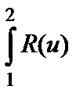du
8. | Show that 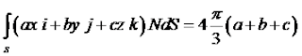  where S is the surface of the sphere x² + y² + z² = 1
SECTION – B
II. | Answer the following questions: |  | 5 x 10 = 50 M
9. | a) | Prove that a finite integral domain is a field
 | (OR)
 | b) | Prove that the characteristic of an integral domain is either a primer or zero
10. | a) | State and prove fundmental theorem of homomrphsm of rings.
 | (OR)
 | b) | Prove that the ring of integers Z is a principal ideal ring.
11. | a) | If a = x + y + z, b = x² + y² + z², c = xy + zx; then prove that [grad a, grad b, grad c] = 0
 | (OR)
 | b) | Find the directional derivative of the function xy² + yz³ + zx² along the tangent to the curve x = t, y = y², z = t³ at the point (1, 1, 1).
12. | a) | Evaluate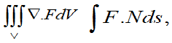  where F = zi + xj + – 3y²zk and S is the surface x² +y² = 16 included in the first octant  between z = 0, and z = 5.
 | (OR)
 | b) | If F = (2x² – 3z) i – 2xy j – 4xk, then evaluate  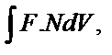  where V is the closed region bounded by the planes x = 0, y = 0, z = 0 2x + 2y + z = 4..
13. | a) | State and prove Stoke’s theorem
 | (OR)
 | b) | Find 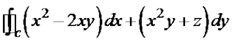  around the boundary C of the region bounded by y² = 8x and x = 2 by Green’s theorem

